Formulärets överkant
SAMBA

SAMBA
Structured Architecture for
Medical Business Activities
Process- and concept analysis of the workflow in Swedish health care for care of one individual subject of care.

Abbreviated version without concept models.

This document
Name: Structured Architecture for Medical Business Activities
Acronym: SAMBA
Date of issue: 23 November 2003
Summary of edition number 1
Revision number: 3
Includes SAMBA process model version 1.81

www.sfmi.org/samba
Information: magnus.fogelberg@vgregion.se

Introduction
The mission of SAMBA has been to develop a process model for the workflow of Swedish health care when dealing with one individual subject of care. The work has included analysis of process models previously developed by several counties. At an early stage it was evident that it is difficult to create a uniform model corresponding to the lot of variants which the former models. The differences between the former models proved to be due to the fact that they had been created from different perspectives. It was therefore of the uttermost importance to identify a common perspective and purpose of the process model.
Within the scope of SAMBA a method to depict a process model was developed, which elucidates all integral parts of the process. The model was divided into three parts. One is a core process, which is the clinical process in health care. The model also consists of a management process, which monitors and evaluates the clinical process based on the mandate to provide health care, and a communication process dealing with information and interaction with the surrounding world.
Thus a partly new process modelling technique was developed. It has then been used to describe the work flow in health care. The model developed seems useful in most situations in health care and can be used to describe the enterprise on different levels of detail.
Analysis and definition of the concepts encompassed in the process model has been within the scope of SAMBA. The conceptual work consists of textual terminological definitions and concept models depicted in UML, Unified Modeling Language. This summary does not include the concept models.
The SAMBA model has become a tool which can be used for enterprise analysis as basis for organisational decisions not only in connection to development of information systems but also in organisational development that is not tied to the use of IT.
The project team members were
Maria Areblad, Landstinget i Östergötland, Maria.Areblad@lio.se
Lars Björkman, Västra Götalandsregionen, lars.bjorkman@vgregion.se
Margareta Ehnfors, Örebro Universitet, margareta.ehnfors@ivo.oru.se
Gösta Enberg, Stockholms Läns Landsting, gosta.enberg@nlpo.sll.se
Magnus Fogelberg, Svensk Förening för Medicinsk Informatik, project team leader, magnus.fogelberg@vgregion
Anders Hallberg, Landstinget i Värmland, Anders.Hallberg@liv.se
Göran Holmberg, Stockholms Läns Landsting, assistant project team leader, vigor@algonet.se
Per-Arne Lundgren, Region Skåne, Per-Arne.Lundgren@skane.se
Torsten Lundmark, Guide Konsult AB, project secretary, Torsten.Lundmark@guide.se
Lars Midbøe, Landstinget i Värmland, Lars.Midboe@liv.se
Nils Schönström, Landstinget i Jönköpings län, nils.schonstrom@ltjkpg.se
Åsa Schwieler, Carelink, asa.schwieler@carelink.se
Britha Sjöberg, Västra Götalandsregionen, britha.sjoberg@vgregion.se
Sven-Bertil Wallin, Guide Konsult AB, sven-bertil.wallin@guide.se
Anna Wikström, Stockholms Läns Landsting, Anna.Wikstrom@lk.sll.se

Process modelling using SAMBA
ISO 9000 defines process as: set of interrelated or interacting activities which transforms inputs into outputs. SAMBA has supplemented the definition with clarifying descriptions, one of which is more important than the others: a process handles one single refinement object. In ISO 9000 input is the refinement object. SAMBA’s clarification means that only one object is refined in each process. It is altered (refined) by the activities of the process and finally constitutes the output. Other objects are also handled in the process, but they are resources or management objects, that are casually used and may be returned or consumed by the activities. But these objects are never part of the final product (the output).
The process contains activities. Each activity may be regarded as a process, because it achieves the transformation of the refinement object. The activity is managed by management objects and makes use of resource objects. In that way the process works on different levels of detail.

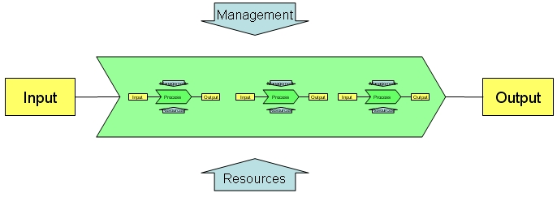

Fig 1. Processes on different levels of detail with refinement object, management, and resources.

The result of the modelling technique used by SAMBA is that the work process “care of one individual subject of care” can be described as three processes running in parallel. There is no need for further processes to describe this core enterprise, but all three are necessary and interrelated. The three processes are
- the clinical process, where the health condition of the subject of care is the refinement object. This is the subject of the health care core enterprise. The objective is to improve the health condition or at least make it known or officially stated (e. g. when the task is to issue a medical certificate). It may also be to keep a good health condition, minimise deterioration or decrease the risk for deterioration (e. g. an immunisation). You get knowledge of the health condition by perceiving it by means of investigations, and what you see in the clinical process is the perceived condition.
- the management process, where the care mandate is the refinement object. This concept is defined in CONTsys (ENV 13940), the European prestandard for concept supporting continuity of care. A care mandate is given to the health care provider in the demand for care stating that a person needs care. The demand for care may be a referral, a personal demand stated by a person on behalf of herself, or a legal order (sentence by court, application for compulsory treatment in hospital). The mandate is pending and gives authorisation to the health care provider to assess the need for care and her possibilities to handle the condition. If the health care provider has a service repository which can be used to handle the need for care, the mandate is confirmed by the healthcare provider with a health care commitment. Then the mandate becomes effective delineating the authorisation of the health care provider and stating the care mission. This is the first refinement of the care mandate. Then the mandate will be further refined when the health care objective is decided and the programme of care established. Decisions to carry out planned activities or services are made in the management process as well as quality assessment regarding the result of the activities compared to their purposes. The mandate is terminated when no more activities can be used to improve the health condition of the subject of care, i.e. when the condition has been restored according to the objective or the provider has no further activities or services to offer within the scope of the mandate.
In the management process the quality management required according to ISO 9001 is carried out.
- the communication process, where information is refined. The input is the demand for care, which starts the communication process and thereby the total workflow of care. The communication process handles information on available resources, requisition of resources, communication with documentation systems and finally information on the final result, that is the information given to the patient or the referring party as an informative discussion, discharge letter, reply to a referral etc.

The communication process receives the first incoming object, the demand for care. The communications process also ends the process with the message of termination as a discharge letter. This process proves to interact with other processes in health care, such as documentation processes, resource handling processes, the administrative and financial processes of the organisation, care processes of other health care providers concerning the same subject of care, the subject’s own process etc. It also interacts with the management process but not with the clinical process. All activities in the clinical process are deliberate and are triggered by decisions in the management process. The management process does not interact with the surrounding world, but alterations in the mandate are made known via the communications process.

In this way the three processes are encapsulated so that the clinical process is encompassed by the management process and the communication process is the outermost layer.

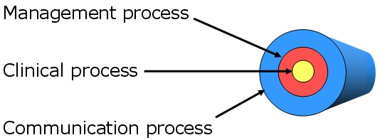

Fig 2. The three layered processes.

The encapsulation of the processes has caused SAMBA to define a process package containing the three processes. It can be shown that every activity that is part of one of the processes is a process package itself with three encapsulated processes. The communication process in such a package, in an activity, can interact with the communication process in a process package on any level of detail.

SAMBA notation rules for the three processes

The three processes have consequently been depicted with the clinical process on top, the management process in the middle and the communication in the bottom.

In each process the refinement object is traced from activity to activity. The refinement object is depicted as a yellow rectangle. The activity is a blue arrow symbol pointing from input to output. The connection between activity and refinement object is depicted with a thin arrow. This arrow does not represent the workflow but only which object a certain activity yields and which activity will be the next one to influence the refinement object.
refinement object
activity
process package

Fig 3. The three encapsulated processes each with its own refinement object.

The work flow moves between the processes so that the management process always triggers activities in the clinical process and the communications process, and these two processes provide resource objects to the management process. The work flow is shown with a thick arrow. The model does not indicate the exact time course. Depending on the circumstances, you can use more or less time for one specific activity.
work flow
Fig 4. The work flow between the three processes.

The process ”care of one individual subject of care” using SAMBA

1. Demand for care – direct referral
The care process always starts when a demand for care is received from another process. It may be a demand issued by a person on her own behalf. It may also be a referral generated in the process of another health care provider. The demand for care contains a pending mandate authorising the receiving provider to make a decision that the person who is subject of the demand for care shall be provided health care services. This pending mandate will start the management process. Its first activity is to decide whether the demand for care shall be clinically assessed or not. This decision is based upon the assessment whether the demand for care accounts for a need for care. A decision that the demand for care shall not be considered may be the output of the management process. This will render a direct termination of the care process by triggering an activity in the communication process which will yield the demand for care as output refined only in the sense that it has been assessed not to be reason for health care activities.
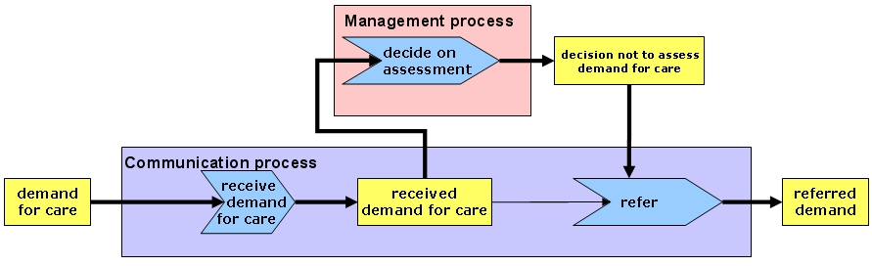
2. Demand for care – clinical assessment
If the demand for care is accepted for clinical assessment it is considered to account for a need for health care activities. This means a decision to assess the health condition as described in the demand for care. That is an act in the management process which controls the start of the clinical process, where the first perception of the health condition of the subject of care is made from information in the demand for care.
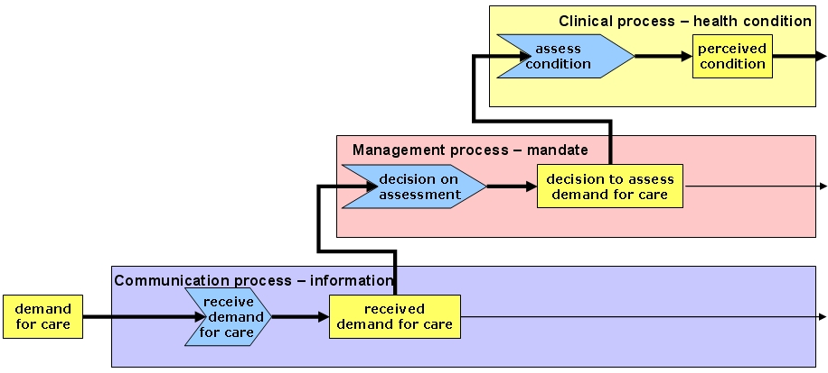

3. Match against service repository – lack of adequate services
In the communication process the received demand for care remains as the refinement object.
In the management process the decision that the demand for care shall be assessed is the refinement object as part of the pending care mandate.
In the clinical process the perceived condition is matched against the service repository of the health care provider. The assessment whether the condition is possible to handle by means of the available service repository is a resource in the management process. It will be the basis for a decision whether or not the provider will accept the pending mandate. If the service repository is inadequate for the perceived condition, the demand for care may be referred to another health care provider. The brief clinical process will then be terminated as well as the management process.
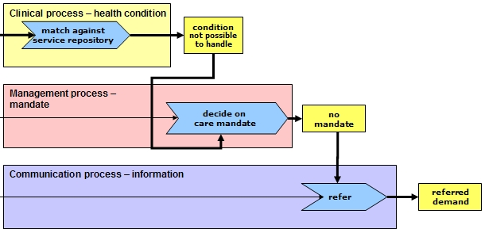

4. Match against service repository – health care commitment stated
The match against the service repository yields an assessment of the condition regarding the possibilities to handle it adequately by means of the provider’s own resources. If the service repository is adequate, a health care commitment is decides and stated. By stating this commitment the provider confirms the care mandate. The next step will be to identify the health issues.
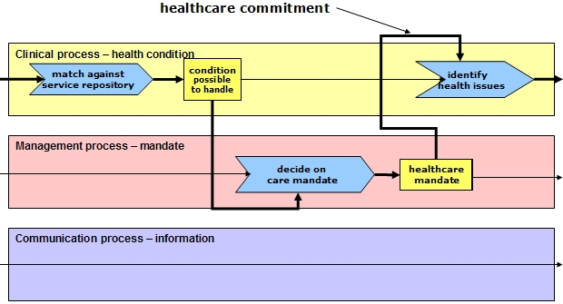

5. Health issue thread/complex, health care objective
By supplementing the clinical information, the appropriate health issue collection can be identified. Such supplementary information may be collected by questioning the subject of care, another carer or by reading older healthcare records. It can also be required from the issuer of the demand for care/referral. Output of this activity is a refined group of problems or issues encompassing the issues which have been identified in the demand for care supplemented with the extra information gathered. The group of issues may include problems which need health care activities as well as problems which are considered not needing specific health care. The group of health issues can be the basis for delineating a health issue thread (which in the prospective view may be better called health issue complex).
The health issue complex is delineated by a health care professional responsible in order to make possible a decision which health issues call for health care activities. This decision is based on the clinical assessment of need for care. In the description of the health care objective a priority ranking of the health issues shall be included. If the process is passed through more times, this step is repeated for an update of priority and health care objective. It is important to note that the objective is defined before care planning begins.
The objective is now matched against services currently available at the health care provider. In paragraph 13 it is shown how the process continues if no service is currently available regardless of an adequate service repository. For instance there may be so many surgical procedures going on that it is impossible to acquire an operation theatre or a surgical team and that the subject of care for that reason has to be referred and sent to another hospital. Another reason to refer the subject of care might be that the waiting list for the activities needed is longer than you can accept.
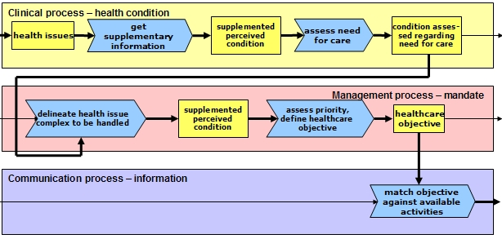

6. Programme of care
An activity list is created consisting of those activities which are considered to be adequate and that are available. With that list available a decision is made that care shall be planned. This decision triggers the next step, when suitable activities are picked out for the handling of the health issues.
The condition is described in relation to the activity plans with a list of activities reasonable to perform, and a programme of care is established. The term programme of care means a systematic list of what shall be done for the subject of care within the scope of the care mandate. A programme of care can be divided into several programmes of care depending on the perspective, primarily which health care professionals are supposed to work according to the programme. In CONTsys the smallest division of a programme of care will be the care plan dealing with what one health care professional will do.
The programme of care will guide booking of resources, and with the aid of the programme of care the activity list is scheduled, provided with names of actors in the planned activities, booking of operation theatre time, requisition of handicap aids as wheelchairs, special devices as transcutaneous nerve stimulators to be adapted to a subject of care etc. The activity list is updated so that activities which are regarded not of current need are deleted from the list. With the help of the activity list and guided by the programme of care decisions on performing planned activities can be made.
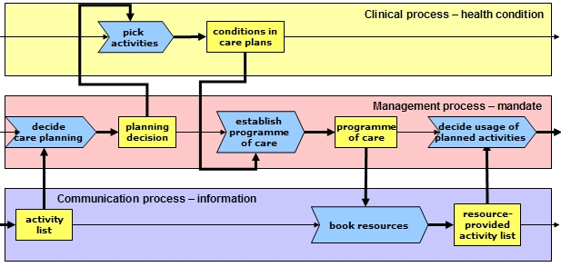

7. Activities – investigation
In the following process steps the principle “investigation – assessment – treatment – evaluation” has been followed. All process steps are passed through, even if a single step may be carried out in short time or even passed over, but all steps are always considered to be carried out.
When the condition is assessed after an investigating activity, this assessment may call for an update of the health care objective. The former objective may prove unrealistic with increased knowledge of the subject’s condition, causing a need for update. The output of this activity is a health care objective which may be altered or unaltered from the former one.
The health care objective is once more matched against available activities, but this time in order to find activities which influence the condition itself and not only have the purpose to increase the knowledge on the condition.
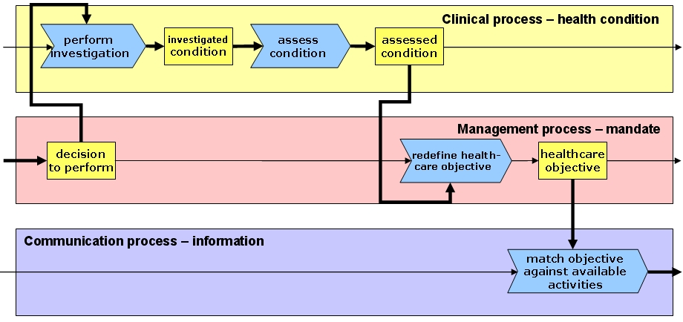

8. Activities – condition influencing procedures
The revised activity list is used for update of the programme of care. Resources are booked and decision is made to perform treatment or other procedures influencing the condition. The treatment yields a treated condition as output.
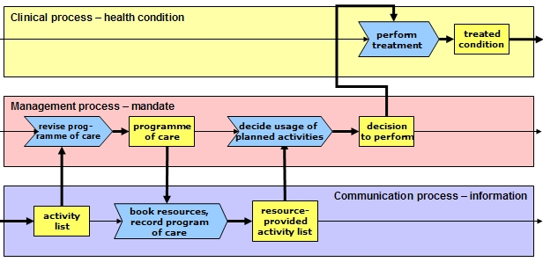

9. Quality check
The treated condition is assessed considering the result, and this is the basis for quality evaluation. Such an evaluation consists of a comparison between the actual result and the intended result (output/purpose, resulting perceived condition/expected perceived condition). The outcome of the quality check describes to what extent the objective has been fulfilled as well as possible exceptions. It is therefore a management of the mandate before redefinition of the health care objective.
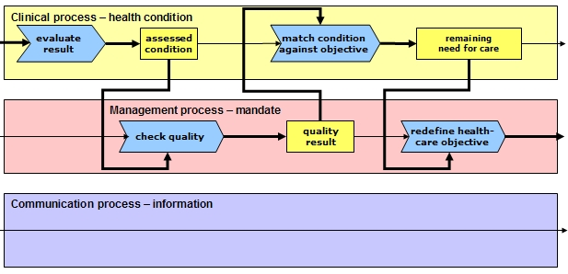

10. End of process – objective fulfilled
If the redefined health care objective is considered to be fulfilled the process is to be terminated. The perceived condition is basis for a decision to revoke the health care commitment (terminate the mandate). The final product (output) of the clinical process will be a perceived condition which has been refined from the one described in the demand for care and entering the clinical process as input when the process started.
The decision to revoke the health care commitment controls the information which is to be delivered on termination. The decision to terminate the process is the output of the management process and the final refinement of the basis for decision in the demand for care. The mandate has been effective all the way through the management process and is terminated when the process stops.
Finally some kind of termination message is issued. It may be information to the subject of care or another carer, a discharge letter or a reply to a lab request. This is the final product of the communication process and thus the termination of the process package which we have identified as the care process in health care for one individual subject of care. The termination message is what is exposed to the surrounding world and the final refinement of a demand for care. It is not possible to restart the clinical process or the management process, which have been finalised, but the communication process may be reactivated in the form that the termination message is regarded as a resource in a new communication process, which can be started by a new demand for care. A very brief demand for care can easily be supported by a former termination message and constitute a good initial information in a new care process. Whether this new process is to be regarded as a new process or a revival of the old process is a matter of rules for care process identification.
This structure of the process causes the follow-up responsibility to be situated in the communications process. Clinical and management responsibility ceases to exist when those two processes are terminated. If a clinical matter would be dropped by mistake, it is not a clinical error but an administrative one. It does not relieve the health care professional from responsibility, but the error is easier to analyse when you know that it has nothing to do with the treatment of the subject of care. It is a pure administrative error.
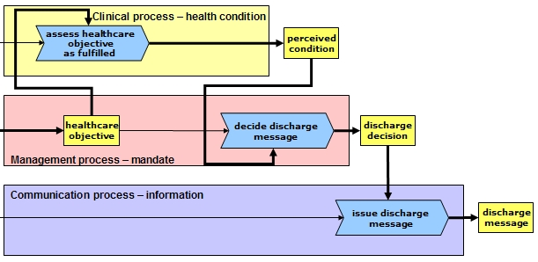

11. End of the process loop – objective not fulfilled
If the revised health care objective is not regarded as fulfilled the care mandate must be updated with a decision that the health care commitment remains/is renewed. Then the remaining health issues are reviewed and possibly new ones included in the new process loop.
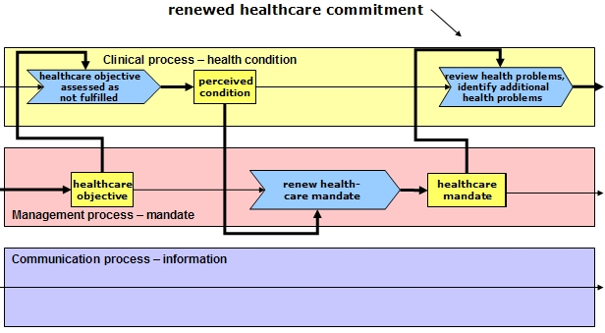
12. Health issue thread/complex, health care objective – iteration if the objective has not been fulfilled
The continued execution of the process is identical with the last iteration, and this step (no 12) is therefore identical with step 4, and a new loop will be passed through.

13. Referral to other healthcare provider
When the objective is matched against adequate services there may be a lack of available resources. Then other measures must be taken. This is a possibility in every process loop.
If no adequate activity is available a referral will be decided. The contents of this referral are based on a current assessment of the condition, and the clinical process is terminated when the input, the perceived condition at the beginning of the process, has been refined to a condition which is to be described in the referral. There is a decision to issue the referral, a demand for care, which is issued in the communication process.
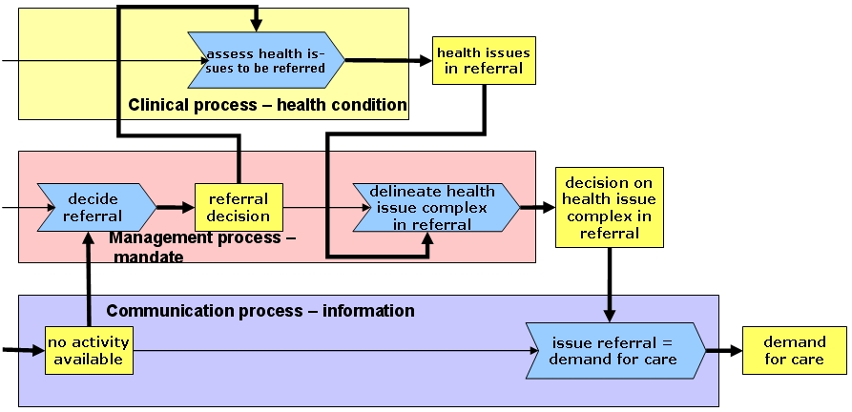

14. Demand for care sent to another health care provider
A demand for care which has been issued by one health care provider and is received by another one will start a similar care process. Then the demand for care is used as a link between the two processes in the sense that all information is transferred to the receiving provider. SAMBA does not deal with rules for this kind of connection, how seamless care is created linking care processes at different providers and how the administrative responsibility should be defined. It is however established in SAMBA that the communication process is the site for linking.
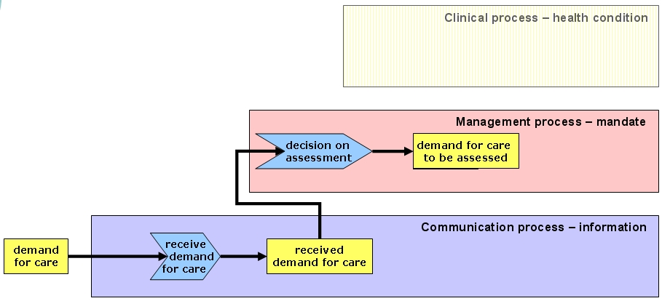

Use of SAMBA
The mission of SAMBA has been to create a logical base for development of information systems in Swedish health care. Such a development must start with an enterprise analysis, and SAMBA is a tool for that. The process model is useful also in other kinds of enterprise analysis, e. g. organisational review and follow-up of the enterprise. The following fields of use can be of topic interest:

- Enterprise analysis: SAMBA describes the health care work flow on a general level. It also gives advice how single activities can be analysed on a more detailed level. The work flow is divided into processes each of which handles one individual refinement object. When developing or changing routines in health care SAMBA gives a good possibility to check that the work flows are consistent so that redundant work is avoided and necessary pieces of work are not lost.
- Security monitoring: SAMBA has identified the quality check of the health care activities. This gives a possibility to continuous control over the activities that they yield the expected result. It also allows a continuous monitoring of exceptions. The model contains a simple method for description of quality exceptions.
The fact that the processes cover the entire task to handle a demand for care makes it possible to identify errors in the work flow. The greatest risk in health care – greater than the risk of clinical errors – is that the patient is exposed to inappropriate waiting time or that her case gets lost between two activities. As the information handling is identified in a separate communication process the logistical flow can be checked without monitoring the clinical handling. If there is a suspicion of erroneous treatment decisions or bad assessments of investigations the management process continuously monitoring evaluation and decisions procedures will discover it as it always runs in parallel with the clinical process.
- Quality management: In development of quality management systems ISO 9001 demands a management process which monitors and manages what is regarded to be the production process in the standard. The SAMBA model has explicitly shown these components within the framework of a process in its defined process package. The SAMBA process package and concept model can be used to supplement the ISO 9000 concept standard for quality management systems.
- Waiting list management: To compare waiting times between different health care providers well defined measuring points in the work flow are required. In the clinical process the investigating and treating activities are the core concepts, and if they are tied to contacts in the way the SAMBA concept model describes they can be mapped to a time line in an administrative system so that the time between the procedures can be registered in a uniform way. Certain activities in the management and communications processes can be registered in the same way, so that e.g. the time from reception of a demand for care to decision of programme of care can be exactly stated.
Decisions to perform activities are supposed to be registered according to the SAMBA model. In a system that handles groups of subjects of care activities which are decided and not yet performed can be counted. This would constitute a measure of waiting list. As all activities are classed in the SAMBA concept model by means of the process model it is possible to decide which kinds of activity that shall be monitored in a system for waiting time registration.
- Costs in health care: The SAMBA model describes the care planning that is carried out during team conferences but also by each health care professional. Every health care professional has a clear opinion of what must be done in every single case. If the model is used for development of information systems in health care the programme of care will become an important management tool. It is possible to calculate the cost of each activity, and therefore the total cost for a programme of care can be calculated and the programme of care used as a budget. If a well formed programme of care is combined with an equally well formed follow-up, the model can be a tool to calculate the financial risk in every activity according to the same principles as the ones used by insurance companies. This would constitute a base for improved cost control and financial planning.
- Documentation of care: A documentation system should be multidimensional. It ought to be problem oriented as well as process oriented. This means that it should be possible to search the system for what is known of a certain health issue, as well with an individual subject of care as in a group of subjects of care. The search must however also be able to search on basis of the care process; so that certain activities can be looked for in the same way. You should also be able to review the order of activities for a certain subject of care. Used in a group of subjects of care this will make possible a deeper enterprise analysis and thereby also a quality development. SAMBA describes the processes as well as the concepts, and therefore it is suitable for development of information models as basis for documentation systems.
During the work with SAMBA the principles for the modelling technique have been discussed in the work with health informatics in the European Standardisation Committee as well in the International Organisation for Standardisation. Great interest has been shown, and it is possible to use the concept system for health care information systems creating a multilingual presentation of the facts. The health care process is approximately the same everywhere in the world but with differences created by rules. Such rules can be included in the management process. Therefore the process model can also be used outside Sweden as has been the case in the revision of the CEN TC 251 prestandards ENV 12967 (HISA) and ENV 13940 (CONTsys).

